**Assignment2**

Topic :Assignment on temperature and humidity sensing and alarm automation using python

Name : k.pugazhenthi

Code :

import random

a=random.random() #temperature

b=random.random() #humidity

print("==========================================================================")

print("==Pgm to notice if the temp and humidity level is good or not in a place==")

print("==========================================================================")

print("==The random temperature generated is :",a)

print("==The random humidity generated is :",b)

if a>80:

if b>80:

print("==Hazarpredected")

else:

print("==High temperature")

elif a==80:

print("==Temperature is high... the ace is need to be cool off... ==")

else:

print("==All good in your place you are safe... \n==The temp and the humidity level is good ")

print("======================================================================")

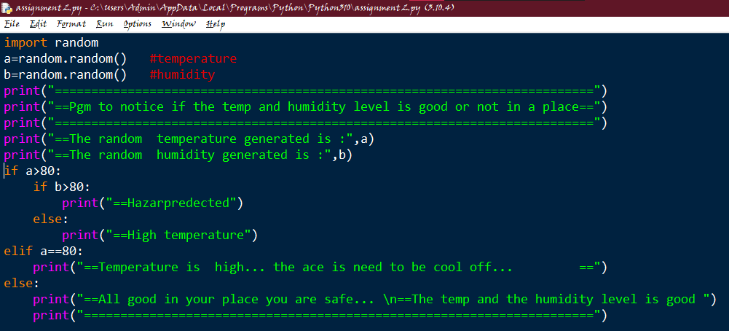

Output :

